Sitemaker1.com Newsletter number 16 – Feb 2005

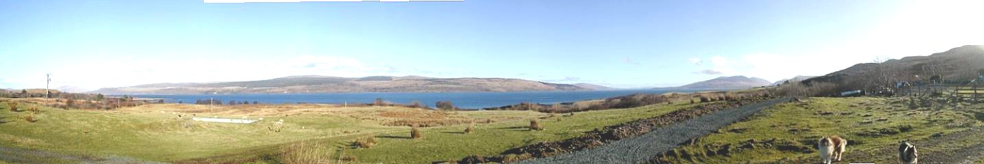

Hi all

Panorama pics
If you have a website that might benefit from having a revolving picture, and you have a digital camera - then visit our panorama pics page. These pictures often cost several hundred pounds. If you can take your own pics and email them to us, then we can create your revolving pic and put it on your site for £25

See http://www.sitemaker1.com/panorama.html for some examples and more info.

What’s a sitemap?
If we are submitting/optimizing your site you may have noticed a new word at the bottom of you home page saying “Sitemap”. Previously we created optimized link pages that would be picked up by search engines; the purpose was so to encourage the engines to improve your rankings for certain phrases. These link pages were linked by small dots on the bottom of you home page. Many engines are now regarding this as simply an attempt to get positioned higher without offering content. To comply with this we are now making these links-pages available to the search engines, only courtesy of text instead of a dot. So rather than clutter up your home page with text we are creating a special page which contains this text. This is the sitemap. If you would like more information about this, please email us.

Microsoft Anti-spyware
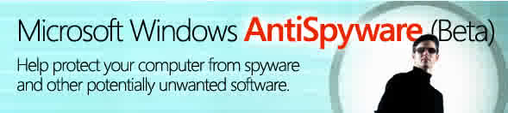
Bill & his team have been getting a conscience about how vulnerable Windows is. To this end he has produced some anti-spyware software that is free. If you would like to download his beta version, it’s here - http://www.microsoft.com/athome/security/spyware/software/default.mspx

Extract from Bill’s FAQ’s

What is spyware?

Spyware is software that collects personal information from you without your knowledge or permission. The information spyware collects can range from all the Web sites you visit to sensitive information including user names and passwords. You could become vulnerable to spyware if you download music from file-sharing programs, free games from sites you don't trust, or other software programs from unknown sources.

Best regards from Pat, Hazel & James

